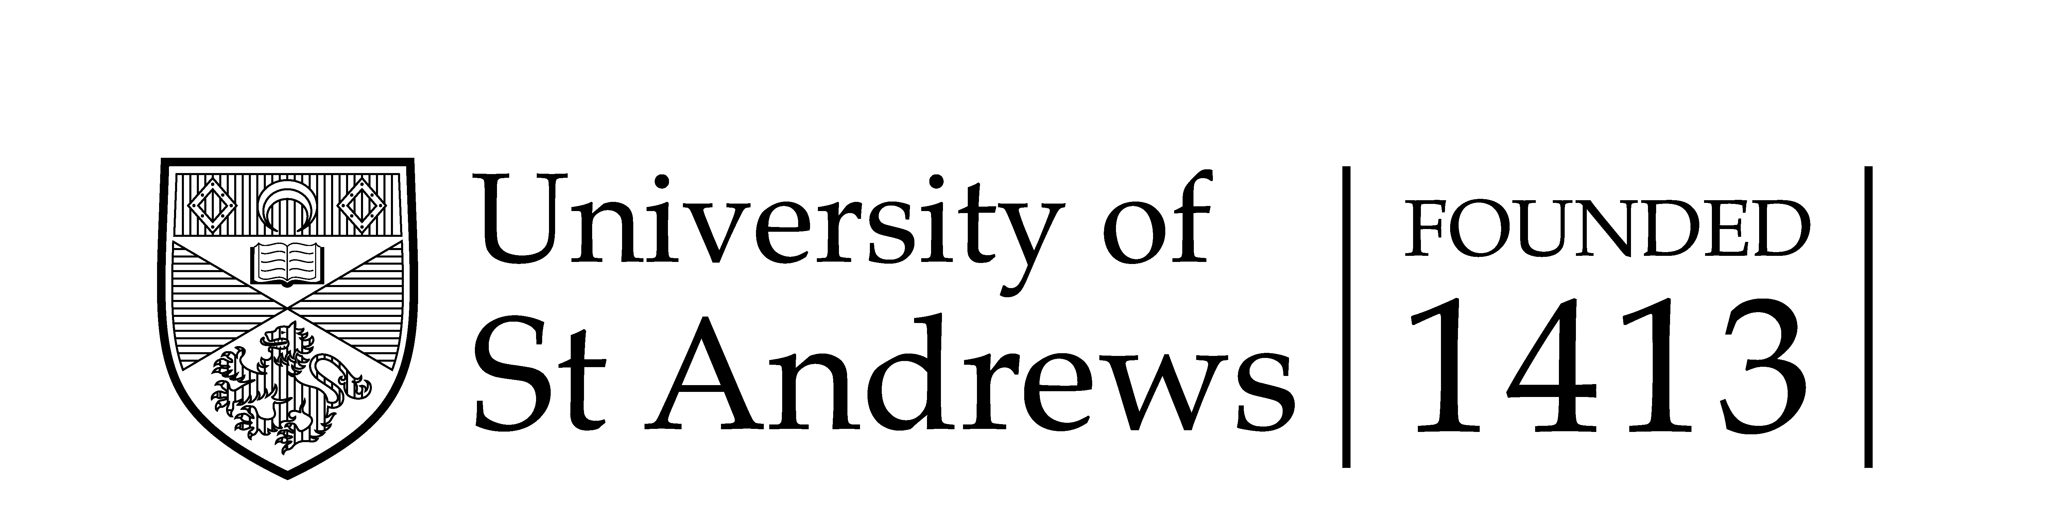

It is essential that Intellectual Property Rights in the materials being uploaded to the database and EU-LAC-MUSEUMS website are observed (eulacmuseums.net, and eu-lac.org for virtual museum). These include Copyright and privacy rights provided by relevant Data Protection legislation.
It is important, therefore, to confirm the following before uploading your item to the database:

Still images of objects or people
- Has the creator of the object in this image or photograph (if living) given consent in writing for it to appear publicly on the website? YES/NO

- Is the object in this image or photograph out of copyright in the country in which it was created? YES/NO
- Has the person who photographed this object (if living) given consent in writing for the photograph to appear publicly in the website? YES/NO

- Is the photograph of this object out of copyright in the country in which it was taken?
YES/NO

- If the object in the image or photograph is held in a museum, art gallery or similar institution, has the institution given consent in writing for the image or photograph to appear publicly on the website? YES/NO

- If there are people in the photograph, have these people (if living) given written consent for the photograph to appear publicly on the website? YES/NO

- If there are (living) children in the photograph, have parents or guardians of the children given written consent for the photograph to appear publicly on the website? YES/NO

Films or videos
- Have the people who made this film (if living) given consent in writing for it to appear publicly on the website? YES/NO

- Is this film out of copyright in the country in which it was made? YES/NO

- If there are people in the films, have these people (if living) given written consent for the film to appear publicly on the website? YES/NO

- If there are (living) children in the film, have parents or guardians of the children given written consent for the film to appear publicly on the website? YES/NO

Audio-recordings
- Has the person who made this audio-recording (if living) given consent in writing for it to be made publicly available on the in website? YES/NO

- Is this audio-recording out of copyright in the country in which it was made? YES/NO

- If the audio-recording records the voice of a living person, has that person given written consent for the audio-recording to be made publicly available on the website? YES/NO

- If the audio-recording records the voice of a living child, have parents or guardians of the child given written consent for the audio-recording to be made publicly available on the website? YES/NO

Records of consents obtained
Can you confirm that a record has been kept of all consents in writing obtained, and that these can be referred to in the event of any claim of infringement of intellectual property being made?
YES/NO

This project has received funding from the European Union’s Horizon 2020
Research and innovation programme under grant agreement No 693669.

